Logical questions

- A conjunction of a cipher conjunction and a cipher count of a double-digit number is 126. What number is it? Find all possible solutions.

- Mrs. Skilful was trying to find a job in a bakery. During the conversation with the manager of bakery, she wanted to tell him how fast she can decorate the cakes. She was very nervous so she made a mistake and she exchanged the number of cakes with the number of minutes. The manager has counted how many cakes she can decorate in five hours and he told her to do it. However, she finished the work 2 hours and 12 minutes after the time. How many cakes has she decorated?

- Try to replace signs on the image 87 with numbers 1, 2, 3, 4, 5, 6, 7, 8, 9, 0.

 -  =  
: - -
↓  .   = 

↓ +  = 

- John has written integers using this rule: Every next number is made from previous number. The previous number is alternately multiplied by 2 or reduced by 3. (For example numbers 1, 2, -1, -2, -5, -10 are ok, but 10, 7, 4, 8, 16, 32 are not ok.) After a few minutes, he summed up last five numbers and the count was 114. What five numbers were last?

- Find out the radius of the bigger circle, if you know that small circles have the radius 1cm. (The circles have 8 bilateral contacts.)
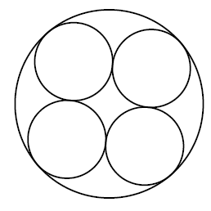

- Tom’s average mark for last year was 4.15. He had 1 four times and a third of his marks were 5. How many marks did he get at least?

- Find all four-figure numbers with ending by the cipher 9 that can be divided by its every cipher.

- Peter asked his grandmother: „How old is my grandfather? “ His grandmother answered: „Both of us are older than 50, but we aren’t 80 yet. If you multiply the count of mine and your grandfather’s age by their contrast, you will get 492.
„Yes! “Peter said after a few minutes. „Grandfather is ...“
How old is his grandfather if you know that he is older than his grandmother?

- On each side of a dice, there is a different prime number lower than 20, written in a way so that the sums of numbers on opposite sides are the same. We put the dice in the first position and roll it the direction of the arrows. On every touch of the dice with the plan, we write the number that is currently at the bottom of the dice.
  - Which number can be on the green square if the sum of the written numbers is 86?
  - Which number has never toughed the plan?

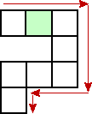
(The plan contains eight squares that have the same parameters as the sides of the dice.)

- Everyone knows Pythagoras’ Theorem: The square of the hypotenuse (c) of a right-angled triangle is equal to the sum of the squares of the other two sides(a and b).
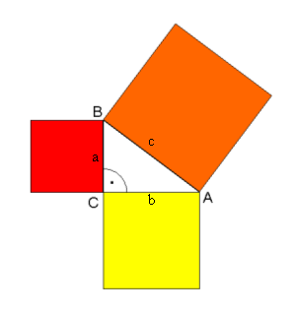

  - Find a way to cut the smaller squares to set up the square of the hypotenuse.
  - How many different ways could we cut the squares of the legs?

- Find the way to write the number 1000 by using nine nines and mathematical operations +, -, x or ÷.

